Mr. Pippo's Pizza

# Problem Statement

Mr. Pippo wants to start a new pizza shop. Everything about his pizzas is unique — the recipe is unique, the taste is unique, and even the shape of pizzas is unique. Instead of having a round shape like every other pizza, Mr. Pippo makes his pizzas in polygon shapes. For example, he can make his pizzas in a triangular shape or in a pentagonal shape.

Before serving a pizza, Mr. Pippo cuts it into triangular pieces. However, there are different ways he can cut the pizza. For example, a pentagonal pizza can be cut in five different ways as shown in the following figure. Each day, Mr. Pippo chooses a particular shape which can only be cut in an odd number of ways. Note that all the five cuts in the figure happen to be rotationally symmetric, but each of them is considered distinct.

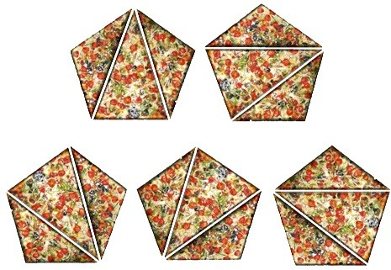

Figure: Different ways a pentagonal pizza can be cut

Your task in this problem is to determine the shape of the pizza. Given the number of ways the pizza can be cut, you have to determine how many sides the pizza has.

Further clarification regarding the ways a pizza can be cut is given below:

A pizza can only be cut by connecting two vertices,

Two cuts on the pizza cannot cross each other, and

For an *n*-polygon there would be exactly (*n*-3) cuts which divide the pizza into (*n*-2) pieces.

# Input Format

First line consists on N – the number of test cases. Following is N lines where each line represents one test case. For each test case, the number of ways the pizza can be cut will be given. The number will be always odd and can be up to 6 digits long. The input is finished when end-of-file is reached.

# Output Format

For each test case, print on a single line the number of sides the pizza has.

# Sample Input

# 3

# 1

# 5

# 14

# Sample Output

# 3

# 5

# 6

**Explanation**

For the first input, there is only one way to "cut" the pizza if the pizza is a triangle. This one way consists of no cuts at all.

For the second input, if there are five ways to cut the pizza, the pizza must be a pentagon, as shown in the figure in the problem description.